**What Is Telnet?**

[**Telnet**](http://adf.ly/14654573/_eaHR0cDovL2VuLndpa2lwZWRpYS5vcmcvd2lraS9UZWxuZXQ=)(**TEL**ecommunication**NET**work) is a network protocol which is used to connect to remote computers over TCP/IP network. Once you establish a connection to the remote computer, it becomes a virtual terminal and will allow you to communicate with the remote host from your local system. A TELNET server generally listens on TCP Port **23**

### Configure Telnet in RHEL :

1. Three RPM are required to configure telnet server in linux.

* xinetd
* telnet-server
* telnet-clinet

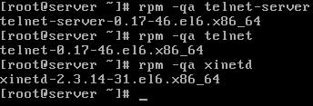

1. Once you have the packages installed, check the **/etc/xinetd.d/telnet** file.

server-etc-xinetd-telnet

1. ensure that **disable** = **yes** is changed to read **disable** = **no**.

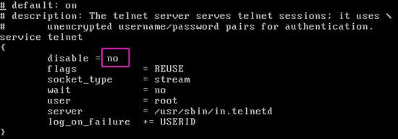

1. Turn the Telnet server **on** using the **chkconfig** command.

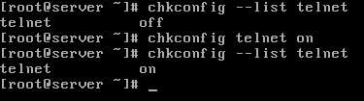

1. Also check xinetd service

server-chkconfig-xinetd

1. You will need to restart the xinetd service.

server-xinetd-restart

1. As I said above root user is not allowed to login from telnet. We need to create a normal user account.

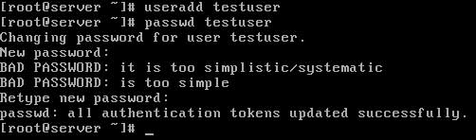

1. To connect with telnet server we need specify server IP address which you can check with ifconfig command. You should test telnet configuration before connecting from client computer.

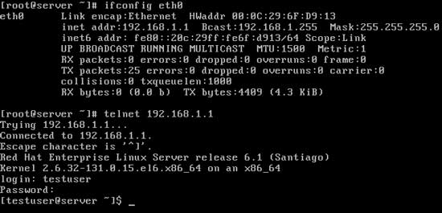

1. To terminate telnet session logout from logged in user.

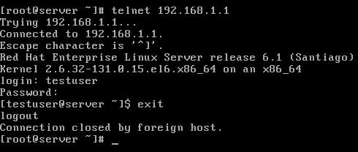

### Configure telnet client in RHEL :

1. On client system we need telnet and xinetd package.

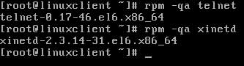

1. check telnet service status on it if it is set to off

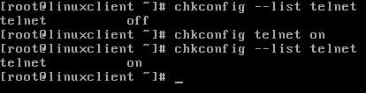

1. open configuration file of telnet

linuxclient-etc-xinetd-telnet

1. check telnet service is enabled make sure that **disable = yes** is changed to **disable = no**

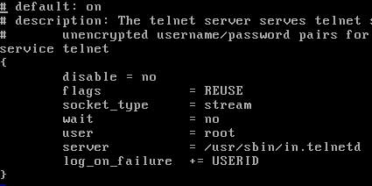

1. restart the xinetd service

linuxclient-xinetd-restart

1. Check connectivity with server

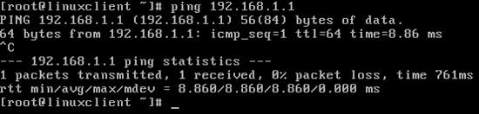

1. We are getting reply of ping from server so we have connectivity with server .connect with telnet server

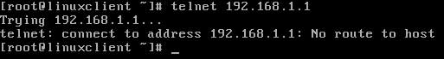

1. Telnet client is unable to connect with telnet server because firewall on server is blocking telnet connection. To solve this error Go on server
2. Run setup command

server-setup

1. select Firewall configuration

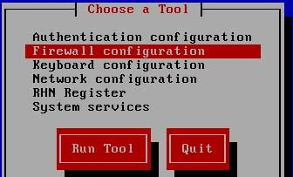

1. Firewall is enabled by default

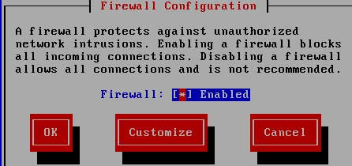

1. To disable the firewall unselect the enable

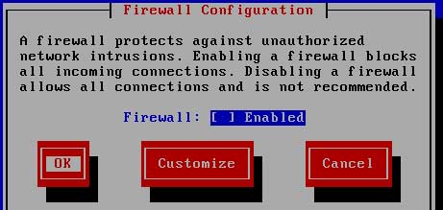

1. Ignore the warning and select OK and press enter

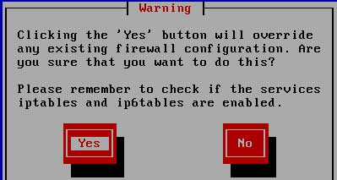

1. Select Quit and press enter to save the configuration

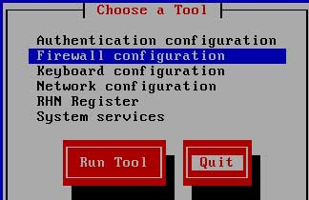

1. restart the xinetd service

server-xinetd-restart

1. Now come back to client system and try to connect with telnet sever

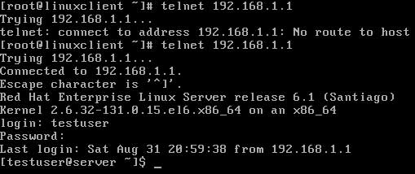

1. This time we have successfully connected with Telnet server. To terminate telnet session logout from testuser.We have successfully configured Telnet client on RHEL 6.